*AI-powered Cleaning Robot*

Bhavya Malhotra   
*CSE AIML*   
*Chandigarh University*Mohali Punjab  
 20BCS6808  
  
Charu Garg  
*CSE AIML*  
*Chandigarh University*Mohali, Punjab  
20BCS6735  
  
Rivi Vig  
*CSE AIML*  
*Chandigarh University*Mohali, Punjab  
20BCS6724  
  
Vyas Vajysh  
*CSE AIML*  
*Chandigarh University*Mohali, Punjab  
20BCS6780

*Abstract*—**With our schedules becoming busier, every second of our time has become more precious than gold. We must spend it wisely and manage it well. The progress of technology has made it possible for us to automate our day-to-day trivial tasks. One such innovation is cleaning robots. Cleaning robots are an efficient solution that not only saves time but also is a blessing for those who are physically incapable of cleaning their surroundings.**

**In this paper, we propose an autonomous and time-controlled AI-powered cleaning robot with features that include vacuuming, wet sweeping, and auto-recharge. This robot is both time and cost-efficient and offers an efficient solution for maintaining a clean and healthy environment. We also explore the ethical and societal concerns that must be addressed to ensure the responsible development and implementation of AI-powered cleaning robots.**

Keywords—AI, robot, automation, cleaning, wet sweeping, vacuum, time-controlled

# Introduction

The use of technology to automate daily tasks has become increasingly common in modern society. As our schedules become busier, time has become a precious commodity, making it essential to use it wisely and manage it effectively. One area in which technology has made significant strides is cleaning, where the introduction of cleaning robots has provided a solution to maintaining a clean and healthy environment while saving time.

In this research paper, we propose an autonomous and time-controlled AI-powered cleaning robot with advanced features, including vacuuming, wet sweeping, and auto-recharge capabilities. This robot is both time-efficient and cost-effective, making it an ideal solution for individuals who are physically unable to clean their surroundings.

The proposed autonomous and time-controlled AI-powered cleaning robot comes equipped with advanced features that make it an efficient solution for maintaining a clean and healthy environment. The robot's primary features include vacuuming, wet sweeping, and auto-recharge capabilities. The vacuum feature allows the robot to pick up dirt and debris from the floor, while the wet sweeping feature uses a wet mop to clean and sanitize hard surfaces. The robot's auto-recharge capability ensures that it can return to its docking station and recharge its battery when necessary, without the need for human intervention. Additionally, the robot's time-controlled feature allows users to schedule cleaning sessions at a convenient time, making it an ideal solution for individuals with busy schedules. The combination of these advanced features makes the proposed cleaning robot a cost-effective and time-efficient solution for maintaining a clean and healthy environment.

While the benefits of AI-powered cleaning robots are apparent, their widespread adoption raises several ethical and societal concerns that must be addressed to ensure their responsible development and implementation. This paper aims to explore the potential benefits of this innovative technology and examine the challenges that must be overcome to ensure its safe and responsible use.

The paper will examine the impact of cleaning robots on the environment, health, and society. Additionally, the ethical implications surrounding the development, deployment, and use of AI-powered cleaning robots will be explored. By analyzing the potential benefits and challenges associated with this technology, this research paper aims to provide insights and recommendations for navigating the opportunities and challenges presented by the use of AI in cleaning technology.

In conclusion, AI-powered cleaning robots offer an efficient and convenient solution to maintaining a clean and healthy environment. However, the development and deployment of these robots must be approached with care and consideration for the potential ethical and societal implications. This research paper aims to provide insights and recommendations for navigating the opportunities and challenges presented by the use of AI in cleaning technology while ensuring its safe and responsible use.

# Literature Review

Cleaning robots have gained popularity in various industries due to their ability to perform repetitive and time-consuming tasks. With the advancement of artificial intelligence (AI), these robots can now operate autonomously and make decisions based on real-time data and feedback. This literature review aims to provide a comprehensive overview of the latest research and development of AI-powered cleaning robots, their capabilities, limitations, and potential applications.

T. Kawaguchi et. al proposed a model that focuses on developing an optimal duct-cleaning robot using a peristaltic crawling motion. The study aimed to compare the performance of robots with different drive brush mounting methods to the proposed method. The need for a duct cleaning robot was highlighted, especially for large buildings with complex duct structures. The previous study developed a peristaltic crawling robot with a 75mm inner diameter, capable of achieving a speed of 9.8mm/s, and a cleaning efficiency of 97.2%. In this study, two additional robots (type-B and type-C) were mounted with different cleaning joints to investigate how the diameter of the cleaning joint and the area of the brush affect the robot's performance. The results showed that the type-B robot, equipped with a 77mm diameter cleaning joint, had a cleaning efficiency of 99.1% and a speed of 6.1mm/s, making it the optimal robot for duct cleaning. Their research has contributed to the development of efficient and effective duct cleaning robots that can save time and reduce costs associated with duct cleaning.

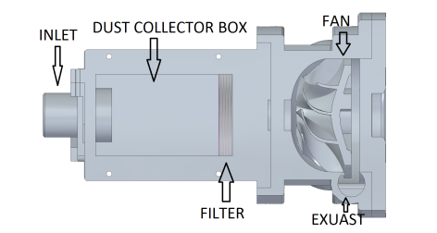

Fig. 1. Cut sectional view of the vacuum system proposed by Wojciech Kowalczyk et. Al

Vacuum robots have been widely used as an alternative to manual vacuum cleaners, but their cleaning efficiency and coverage area are limited due to the fixed inlet on the bottom side. To address this limitation, Wojciech Kowalczyk et. al proposed using a flexible vacuum inlet for improved performance. In 1997, the Koala autonomous vacuum cleaner was introduced, which featured a two-degrees-of-freedom robotic arm with a cleaning head and adaptive manufacturing to reduce costs. The robot is equipped with LIDAR and web camera sensors and a touchscreen display for information. A high-level controller enables the robot to follow a virtual path while avoiding obstacles and identifying potential design problems. The robot was designed using Solid Edge 2020 software and features a four-degrees-of-freedom robotic arm, a four-wheel-drive platform, a 7-inch touchscreen holder, and two batteries with three controllers. The Koala robot serves as an example of how robotics technology can be used to enhance vacuum cleaning performance and improve coverage area.

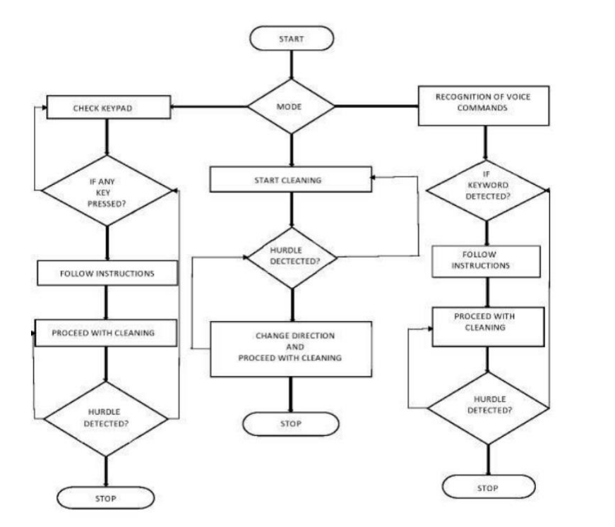

Fig. 2. Flow Chart displaying the working of the model proposed by Amith Kumar K.S. et. Al

Amith Kumar K.S. et. al proposed a model that used artificial intelligence to provide the robot with intelligent scheduling and motion control for optimized operation. The robot could perform both dry and wet cleaning, making it highly efficient. It was designed primarily for household purposes and offered both automatic and manual control modes, providing flexibility for users. Its primary objective was to assist the elderly and physically challenged individuals in the floor cleaning process, and the use of sensors and human input in decision-making allowed for the replacement of manual labour. Furthermore, the smart floor cleaning robot was cost-effective compared to other robots, making it more accessible to the general public.

Beach pollution is a global problem that has led to the development of various beach cleaning systems. These systems aim to collect waste from beaches quickly and efficiently, reducing the negative impact on aquatic life and human health. Researchers and robotics experts have designed robots that can navigate the beach, collect trash, and transport it to a deposit. PWM speed control has been used for the structural framework of the robots. HS-GreenFist is a low-budget robot that was designed to compete in the open category of LARC. Another robot was proposed that can collect garbage on the beach using wireless communications. However, a project that separates waste material through the principle of density difference can only be used manually. These papers highlight that different systems have been developed to combat beach pollution, with varying complexities, costs, and limitations.

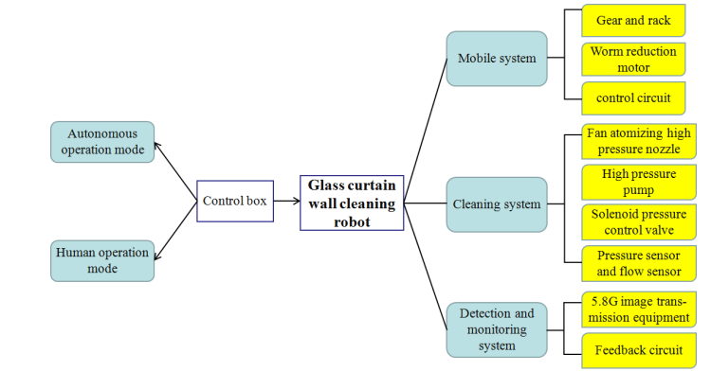

Fig. 3. The overall technical route of the glass curtain wall cleaning robot

The design of a rail-type cleaning robot for cleaning large glass curtain walls in high-rise buildings was proposed by Guoqing Wang et. al. The paper emphasized the difficulties in cleaning large glass curtain walls manually and the risks associated with such methods. It was noted that the traditional manual cleaning method was costly, inefficient, labour-intensive, and risky. The article described the design and development of a lightweight and flexible rail-type cleaning robot that was controlled by a 51 microcomputer, making it suitable for cleaning operations on large glass curtain walls. The robot was designed to reduce the risk factor and labour intensity of cleaning operations. The article highlighted the importance of improving robot technology and making people gradually accept robot cleaning operations. The glass curtain wall cleaning robot was seen as having an important role in reducing the incidence of safety accidents and improving work efficiency.

In conclusion, AI-powered cleaning robots have demonstrated great potential in various industries, and there have been several developments in the field, including duct-cleaning robots, vacuum robots, smart floor-cleaning robots, beach cleaning systems, and rail-type cleaning robots. However, more research is needed to improve their capabilities, reduce their limitations, and identify new potential applications.

# Proposed model

Introduction:

In this paper, we propose the design and implementation of a mobile robotic system for automated mopping and floor cleaning. The system is composed of an Arduino-based control board, Bluetooth module, motor driver, relay board, and ultrasonic sensors. Additionally, a 12V diaphragm pump is used for spraying water on the mop. The power supply consists of three 18650 lithium-ion batteries connected in series, providing an optimal 12V output. The robot is controlled through a Bluetooth Serial Controller app installed on a smartphone. This paper aims to present the detailed methodology of our proposed system and its effectiveness in automating floor cleaning tasks.

Materials and Methods:

The main circuit board was designed using an Arduino Uno microcontroller board. After completing the circuit board, the Bluetooth module was connected, followed by the relay board and motor driver. The motors were then connected to the motor driver, and the three ultrasonic sensors were connected to their respective pins using jumper wires. The 12V diaphragm pump was used for spraying water on the mop, with the inlet pipe made of 8mm thickness tubing and the outlet pipe made from a thinner pipe sourced from a drip infusion system. A small 200ml bottle was used as a water reservoir, and the inlet and outlet pipes were connected as per the marking on the water pump.

The power supply consists of three 18650 lithium-ion batteries, each with a capacity of 3000mAh. The batteries were connected in series, providing a total output of 12V, which is optimal for our application. To achieve this, three single cell holders were hot glued on a hard board piece and connected in series, as we could not find a 3-cell holder. A switch was also connected to turn the robot On/Off. The mop was attached to the robot through a hole drilled earlier and with hot glue.

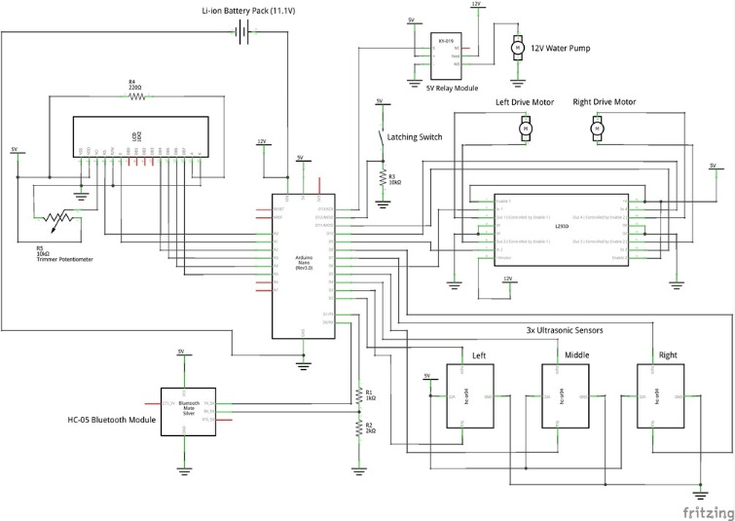

Fig. 4. Proposed Model for AI powered cleaning robot

To upload the code, the Arduino was removed from the circuit, as there should not be anything connected to the Rx and Tx wires of Arduino while uploading the code. After uploading the code, everything was put back in place. The robot was controlled through a Bluetooth Serial Controller app installed on a smartphone. The app was configured to work with our robot by selecting Potrait orientation, turning on the White Background, and setting Button Size under Potrait to 100. Buttons 2, 5, 6, 7, and 10 were made visible, and their respective commands were set as 'F', 'L', 'P', 'R', and 'B', with stop commands as 'S', 'S', 'p', 'S', and 'S', respectively. The optional speed control feature was also added with Low, Medium, and Maximum speed options, with commands '1', '2', and '3', respectively.

Results:

The designed mobile robotic system was tested, and the LCD displayed the 'Welcome' message correctly upon turning on the robot. The Bluetooth module was paired with the smartphone, and the robot was controlled through the Bluetooth Serial Controller app. The robot movement and command display on the LCD were observed to be functioning correctly. Any problems with the motor driver connections were rectified.

Discussion:

The proposed mobile robotic system effectively automates floor cleaning tasks with the use of an Arduino-based control board, Bluetooth module, motor driver, relay board, and ultrasonic sensors. The system's power supply consists of three 18650 lithium-ion batteries connected in series, providing an optimal 12V output. The use of a 12V diaphragm pump for spraying water on the mop ensures efficient and effective cleaning. The system is controlled through a Bluetooth Serial Controller app installed on a smartphone, with the optional speed control feature providing further customization. Overall, the proposed system provides a cost-effective and efficient solution for automating floor

##### Acknowledgment

----The preferred spelling of the word “acknowledgment” in America is without an “e” after the “g”. Avoid the stilted expression “one of us (R. B. G.) thanks ...”. Instead, try “R. B. G. thanks...”. Put sponsor acknowledgments in the unnumbered footnote on the first page.

##### References

1. <https://www.mdpi.com/2673-2688/3/1/11>
2. <https://www.diva-portal.org/smash/get/diva2:1444501/FULLTEXT01.pdf>
3. <https://www.ncbi.nlm.nih.gov/pmc/articles/PMC8493645/>
4. <https://www.mdpi.com/2076-3417/11/22/10702>
5. <https://www.mdpi.com/2076-3417/11/17/8076>
6. <https://blog.tensorflow.org/2020/01/ecovacs-robotics-ai-robotic-vacuum.html>
7. M. Dorigo, V. Trianni, E. S¸ ahin, R. Groß, T. H. Labella, G. Baldassarre, S. Nolfi, J.-L. Deneubourg, F. Mondada, D. Floreano, et al., ”Evolving self-organizing behaviors for a swarm-bot,” Autonomous Robots, vol. 17, no. 2-3, pp. 223–245, 2004.
8. V. Trianni, E. Tuci, C. Ampatzis, and M. Dorigo, ”Evolutionary swarm robotics: A theoretical and methodological itinerary from individual neuro-controllers to collective behaviours,” The horizons of evolutionary robotics, vol. 153, 2014.
9. G. Baele, N. Bredeche, E. Haasdijk, S. Maere, N. Michiels, Y. Van de Peer, T. Schmickl, C. Schwarzer, and R. Thenius, ”Open-ended on-board evolutionary robotics for robot swarms,” in 2009 IEEE Congress on Evolutionary Computation, IEEE, 2009, pp. 1123–1130.
10. G. S. Nitschke, M. C. Schut, and A. Eiben, ”Evolving behavioral specialization in robot teams to solve a collective construction task,” Swarm and Evolutionary Computation, vol. 2, pp. 25–38, 2012.
11. G. K. Venayagamoorthy, L. L. Grant, and S. Doctor, ”Collective robotic search using hybrid techniques: Fuzzy logic and swarm intelligence inspired by nature,” Engineering Applications of Artificial Intelligence, vol. 22, no. 3, pp. 431–441, 2009.